Belford Community Cinema presents:
THE LAST SHEPHERDS
A Vanishing Way of Life on The Cheviot Hills
UPSTAIRS at Bell View, 33 West Street, Belford NE70 7QB
Wednesday 19th February 2020
Doors 6.30pm/7pm start. Running time: 88 mins. £4 on the Door
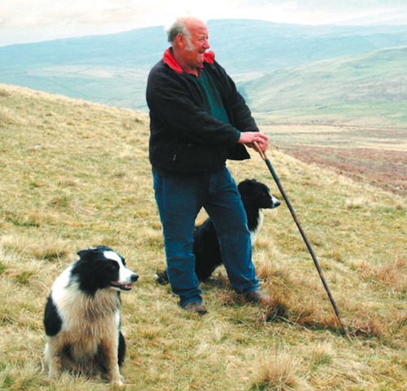

Shot in 2004 this is a captivating glimpse of a fading era. The Last Shepherds follows, Dave, Stewart and his wife Gwen as they tend their flocks on the rugged Cheviot Hills.

Dave, who’s keen on preserving the customs of the past, has worked on the same farm for over 40 years. He carves his own walking sticks, makes his own sheepdog whistles from pieces of tin, and enjoys nothing more than a night of music and memories at a shepherds’ get-together on a winter’s night.

Inspirational and evocative, this fascinating look at shepherding traditions chronicles a way of life that is soon sadly destined to become a distant memory.

